Introduction
Objective list theories believe in the existence of objective prudential goods: even though one can be a couch potato, he/she chooses more virtuous activities to approach happiness(Haybron, 2020). Nevertheless, individuals still have subjective understandings of objective goods, which I refer to as an essential state of happiness.
Based on this understanding of happiness, I adopt the logic of "Four Fields of Knowledge" (Schumacher, 1978) to illustrate the two processes of effective measurement :
- Respondents have a clear understanding of their personal happiness (I - inner)
- They convey their sense of happiness accurately and completely to the test (inner-externality)
However, insurmountable barriers hinder the satisfaction of these two processes. Therefore, this essay argues that happiness cannot be measured by subjective well-being tests (SWB) (Stone et al., 2013).
First process: realization of the self
In Tao Te Ching, Lao-Tzu believes that " He who knows himself is enlightened." Knowing oneself is to discover one's feelings, thoughts, and beliefs fully (Gertler, 2020). And since happiness is an inner experience, knowing will be the zero condition to discover one's essential state of happiness.
Because happiness blends inseparably with physical sensation, one's knowledge of externality will first affect one's knowing. To learn the external world, Locke writes, "Tis therefore the actual receiving the ideas from without that gives us notice of the existence of other things (Rockwood, 2018)." That means the knowledge about externality doesn't build from established beliefs toward externality but is from our raw sensation. To discern these two sources, individuals' perception needs to be a "dynamic searching for the best interpretation of available data" (Gregory, 2015), and I interpret this search as self-consciousness.
Being self-conscious takes two steps. By invoking system II, individuals first direct their attention to effortful mental activities and once autopilot behaviors, providing a threshold for gaining subjective experiences (Kahneman, 2011). Nearly simultaneously, metacognition involves monitoring one's cognitive states, ensuring individuals view their own thoughts critically. The activation of system II and metacognition pushes an individual to the boundary of the known, and the process of taking the unknown into the known is self-conscious.
However, barriers hinder human beings to discover the self. Biologically speaking, human beings have a natural tendency to conserve energy and thus evade the activation of System II, especially on tasks that can be done with System I (Kahneman, 2011). Moreover, without mindfulness, the attention on externality is likely to be divided, which individuals may fail to realize. As Corteen and Wood (1972) have discovered, when words didn't consciously perceive by participants, they still established meaning in their minds. With all barriers to realizing the self, Kants says a man cannot "determine with certainty what would make him truly happy; because to do so he would need to be omniscient. (Kant, 1889)"
The idea of being omniscient is to transcend and discover one's essential state of happiness. But even if a being believes that he attain a sense of happiness, it may be a fallacy and not the known. To illustrate this claim, I adopt Tal Ben-Shahar's (2007) model and analyze possible cognitive limitations that hinder each archetype to transcend. For every individual who has a belief in present and future happiness, one can fill into a quadrant.
Figure 1
The four quadrant
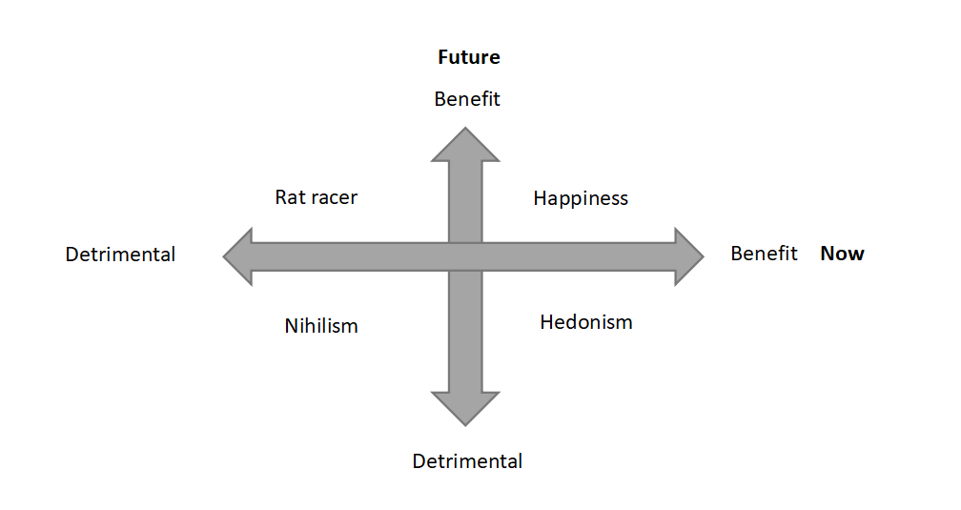
Note. The image is created based on Tal Ben-Shahar. (2007). Happier : learn the secrets to daily joy and lasting fulfillment. Mcgraw-Hill.
Hedonism: ultimate happiness is attained
By taking psychoactive drugs and performing religious behaviors, human beings can intentionally alter their states of consciousness (Cacioppo & Freberg, 2019, p. 215). With this artificial change of beliefs, hedonistic drug takers regard instant satisfaction as happiness and disregard their future. However, if happiness exists in the form of eudaimonia, the overall experience in life is related to one's experience toward happiness. Since hedonists blind future possible happiness, transcendence can only occur when they realize the mistake of regarding instant excitement as ultimate happiness.
【Overall achievement--needs further clarification, even include the events after death.[ oxford handbook of happiness】
Nihilism: happiness died
During World War II, numerous people failed into learned helplessness and believed that they lost both present and future happiness. According to Karl Jasper's theory, they fail into a "limit situation", believing that only the external locus of control exists (Valdes-Stauber, 2016). However, a limit situation also can "becomes one's destination in the realization of one's existence", provoking people to ask for higher happiness (Jacobsen, 2008). Frankl (2006) accepted his unavoidable sufferings bravely, believing potential meaning is possible to find within. People with serious chronic diseases learn to adapt to their impairments and transcend themselves (Charmaz, 1995). Thus, if the higher happiness integrates the meaning of pain, nihilists evaluate their happiness based on their "existence" rather than their "essence" (Sartre, 1946), disregarding the potential of transitoriness.
Happiness: the distinction between evaluation and beliefs
Happiness is the archetype that has the highest possibility of approaching the knowing since they believe that they have the potential of discovering one's maxim of happiness. With the belief to transcend, they take happiness more as a dynamic skill that detaches from established experiences and momentary states. However, while the perception turns to explicit rating within oneself, possible bias may occur during the construction of the frame. For instance, about what contributes to one's happiness, individuals take certain aspects as the main cause, but the ignored intricate associations among these aspects are also essential for gaining happiness. As Gestalt psychology illustrated, one's understanding "seems to depend upon relations among the stimuli rather than upon the individual stimuli as such (Kohler, 1967)." Therefore, the transition between perception and evaluation can undermine the known.
Rat Racer: serving for happiness
Rat racers "subordinate the present to the future" and "suffer now for some anticipated gain" (Tal Ben-Shahar, 2007), regarding their sacrifice in present happiness is meaningful. However, this destiny-orientated pursuit ignores the impact of the shift in reference points. Under this "finite game" (which is played to win)(Carse, 2012), rat racers keep aiming for a higher reference point and leave themselves in a state of loss. Due to loss aversion, the same amount of gain from the past and loss from now cannot subjectively offset each other (Kahneman, 2011). Without possible transcending, which is to gain happiness from journeys, rat racers accumulate their loss and search for happiness continuously with improper direction.
Figure 2
Utility function
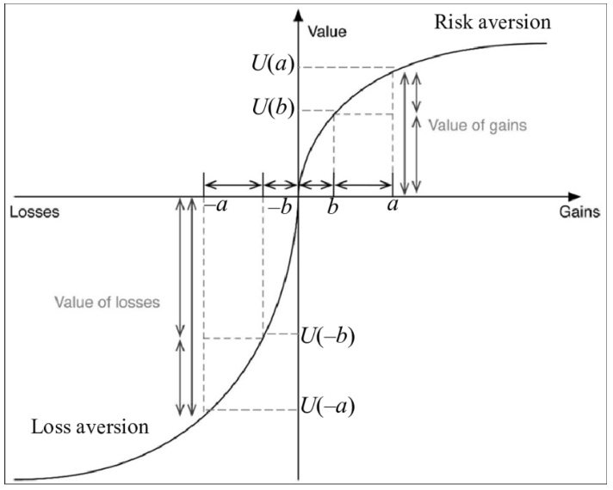
Note.
Second process: the interaction between internality and externality
Now the respondents need to convey their understanding to the test. To ensure the second process proceeds successfully, two conditions need to be satisfied:
2.1)Individuals are willing to convey their understanding of externality fully and accurately
2.2)externality constructs a frame that can capture individuals' understanding fully
Firstly, for 2.1 condition, tests' intentions can strongly affect individuals' willingness. If the test aims to achieve the externality's purpose, such as collecting data for scientific research, moderate anonymity facilitates the authenticity by lowering social desirability pressures (Lelkes et al., 2012) However, if the respondents regard the measurement as a way of knowing himself, one main question will arise: can a man be honest to himself when he/she stays alone?
The existence of cognitive dissonance can undermine respondents' willingness to convey their understanding. For rat racers, reporting a high level of happiness (action) allows respondents to stay consistent with the social expectation of wealth and fame (belief), even though they realize the lack of happiness. Moreover, under the value system that "unhappiness is a symptom of maladjustment" (Frankl, 2006), respondents may hide their willingness further to conform to social desirability and reduce their cognitive dissonance.
Secondly, to satisfy 2.2 condition, an effective frame first needs to ensure the testing questions can capture all respondents' personal understandings. Therefore, researchers use "meaning" in tests without clarification, or a broad definition such as "as the sense made of" (Steger et al., 2006). But the lack of precision means respondents' personal understandings need to be clear. If the first process fails, then 2.2 condition will hard to be achieved.
Alternatively, the test can turn out to be more precise by including more potential factors, such as "non-hedonic sources of happiness and suffering (Stone et al.,2013)." However, precision can bring more challenges. For instance, confronting a challenge successfully can bring competence, which is normally regarded as a promoter of happiness. However, if respondents feel a lack of autonomy while they handle the tasks, competence then cannot enhance their happiness (Ryan & Deci, 2000). Therefore, if the measurement improves the evaluation by incorporating more correlated sources, such as competence, it needs to take even more correlated factors to ensure the test is unbiased.
Not only does the trade-off between broadness and precision can brings a challenge, but also the cognition of society can limit the frame of the test. Influenced by culture, measurement in a collectivist society attaches more importance to contributions toward groups, likely to regard these efforts are more eudaimonic than personal growth. Influenced by the features of an era, society's understanding of happiness diverges with individuals'. For instance, in Song Dynasty, Su Tungpo spoke truth to power and thus was exiled to undeveloped land such as Lingnan. Even though he suffered, he still perceived a strong sense of happiness, expressing that in his poem: "With three hundred litchis every day and night; I am willing to be a Lingnan man for the rest of my life." (Lin, 2018) The society aimed to suppress him and reduced his happiness, but Tungpo "amor fati"--loves his fate (Han-Pile, 2009). The diverged understandings between individual and externality mean, if the externality constructs a measurement, it would hardly be not biased.
More importantly, individuals can hardly falsify that society and individuals have diverged understanding toward happiness. For instance, It is convincing that social connection can promote the development of self-esteem (Maslow, 1943), but is it possible that society overly reinforces the role of externality on one's happiness? Under the encouragement of social networks, one may falsely regard solitude as loneliness. Therefore, individuals' intrinsic understanding of happiness can be veiled. Society believes the test enhances its convergent validity, but is this still individuals' subjective well-being? Or is it more about society-encouraged well-being?
Conclusion
This essay argues happiness cannot be measured by a subjective well-being test (SWB) by examining two processes.
First, when a man evaluates his/her inner happiness, he/she first needs to approach the state of knowing. However, even if the man believes that he/she achieves knowing, he/she may be hindered by cognitive limitations as explained by archetype analysis.
Second, when the respondents convey their understanding to the test, their willingness to convey and the test's frame affect the extent that happiness is reflected. Respectively, cognitive dissonance can undermine one's willingness to convey, and the trade-off between broadness and preciseness brings challenges to construct questions.
Last, I argue that the frame of the test is highly influenced by society's cognition, but instead, it should be based on individuals' cognition of happiness. This divergence between individuals' and externality's cognitions can hardly be proved under the influence of mainstream culture.

References
Cacioppo, J. T., & Freberg, L. (2019). Discovering psychology 3e : the science of mind (p. 215). Cengage.
Carse, J. P. (2012). Finite and infinite games : a vision of life as play and possibility. Free Press.
Charmaz, K. (1995). The Body, Identity, and Self: Adapting to Impairment. The Sociological Quarterly, 36(4), 657–680. https://www.jstor.org/stable/4121346
Corteen, R. S., & Wood, B. (1972). Autonomic responses to shock-associated words in an unattended channel. Journal of Experimental Psychology, 94(3), 308–313. https://doi.org/10.1037/h0032759
Frankl, V. E. (2006). Man’s Search for Meaning. Beacon Press.
Gertler, B. (2020). Self-Knowledge (E. N. Zalta, Ed.). Stanford Encyclopedia of Philosophy; Metaphysics Research Lab, Stanford University. https://plato.stanford.edu/entries/self-knowledge/
Gregory, R. L. (2015). Eye and Brain : The Psychology of Seeing - Fifth Edition. Princeton University Press.
Han-Pile, B. (2009). Nietzsche and Amor Fati. European Journal of Philosophy, 19(2), 224–261. https://doi.org/10.1111/j.1468-0378.2009.00380.x
Haybron, D. (2020). Happiness (E. N. Zalta, Ed.). Stanford Encyclopedia of Philosophy; Metaphysics Research Lab, Stanford University. https://plato.stanford.edu/entries/happiness/#HedVerEmoSta
Jacobsen, B. (2007). Invitation to existential psychology : a psychology for the unique human being and its applications in therapy. John Wiley.
Kahneman, D. (2011). Thinking, Fast and Slow. Farrar, Straus and Giroux.
Kant, I. (1889). Foundations of the Metaphysics of Morals. http://www.sophia-project.org/uploads/1/3/9/5/13955288/kant_foundations.pdf
Kohler, W. (1967). Gestalt psychology. Psychologische Forschung, 31(1), XVIII–XXX. https://doi.org/10.1007/bf00422382
Lelkes, Y., Krosnick, J. A., Marx, D. M., Judd, C. M., & Park, B. (2012). Complete anonymity compromises the accuracy of self-reports. Journal of Experimental Social Psychology, 48(6), 1291–1299. https://doi.org/10.1016/j.jesp.2012.07.002
Maslow, A. H. (1943). A Theory of Human Motivation. Psychological Review, 50(4), 370–396.
Rockwood, N. (2018). LOCKE ON EMPIRICAL KNOWLEDGE. History of Philosophy Quarterly, 35(4), 317–336. https://doi.org/10.2307/48570921
Ryan, R. M., & Deci, E. L. (2000). Self-Determination Theory and the Facilitation of Intrinsic Motivation, Social Development, and Well-Being. American Psychologist, 55(1), 68–78.
Sartre, J.-P. (1946). Existentialism is a humanism . Yale University Press.
Schumacher, E. F. (1978). A guide for the perplexed. Harper & Row.
Steger, M. F., Frazier, P., Oishi, S., & Kaler, M. (2006). The meaning in life questionnaire: Assessing the presence of and search for meaning in life. Journal of Counseling Psychology, 53(1), 80–93. https://doi.org/10.1037/0022-0167.53.1.80
Stone, A. A., Mackie, C. J., Policy-Relevant, I. A., & National Research Council (U.S.). Committee On National Statistics. (2013). Subjective well-being : measuring happiness, suffering, and other dimensions of experience. The National Academies Press.
Tal Ben-Shahar. (2007). Happier : learn the secrets to daily joy and lasting fulfillment. Mcgraw-Hill.
Valdes-Stauber, J. (2016). [Man at the Frontier of his Being: Scope of the Concept of “Limit Situation” in Psychiatry and Psychotherapy Following Jaspers’ Existential Ontology]. Fortschritte Der Neurologie-Psychiatrie, 84(1), 19–27. https://doi.org/10.1055/s-0042-101167
Yutang Lin. (2018). The Gay Genius：The Life and Times of Su Tungpo. Hunan Literature and Art Publishing House.

